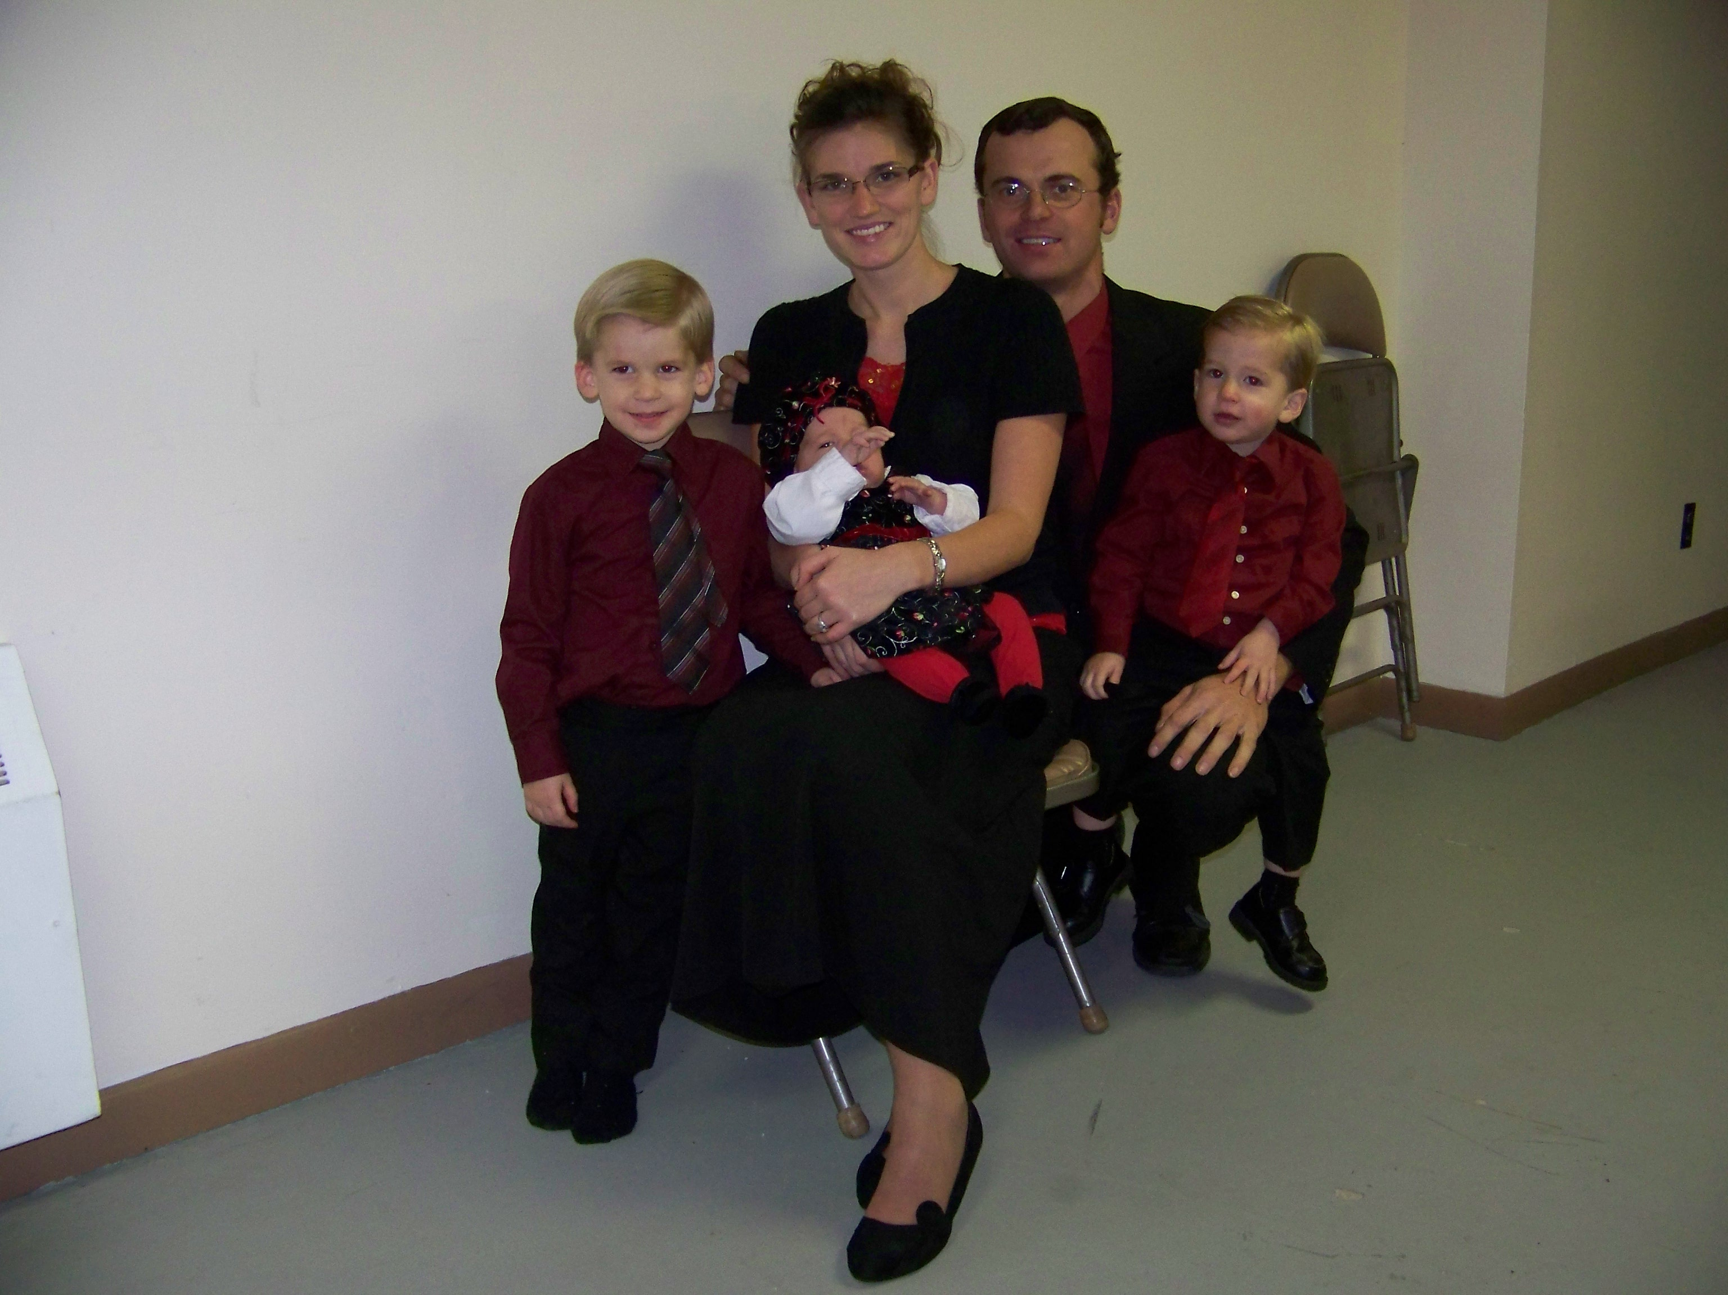
Jos. 24:14 Fear the LORD, and serve him in sincerity and in truth:
Jos. 24:15 But as for me and my house, we will serve the LORD.
Jos. 24:18 Therefore will we also serve the LORD; for he is our God.
Jos. 24:24 The LORD our God will we serve, and his voice will we obey.

We need a Total Dependence on The Lord our God.

When wealth is lost, nothing is lost;
When health is lost, something is lost;
When character is lost, all is lost!

Fame is a vapor, popularity an accident, riches take wings.
Only one thing endures and that is character.
Abraham Lincoln

Education begins at mother's knee, and every word spoken within the
tittle- tattle of little children tends towards the development of character.

2Thes. 1:11 Wherefore also we pray always for you, that our God would
Happy Birthday Jessica
Count you worthy of this calling, and fulfil all the good pleasure of his goodness, and the work of faith with power:

Your Daddy loves you and God bless you on your 26th birthday

Ps 26:3 For thy lovingkindness is before mine eyes: and I have walked in thy truth.

